Power BI Assignment 2 – DAX & Data Visualization
Stp1:
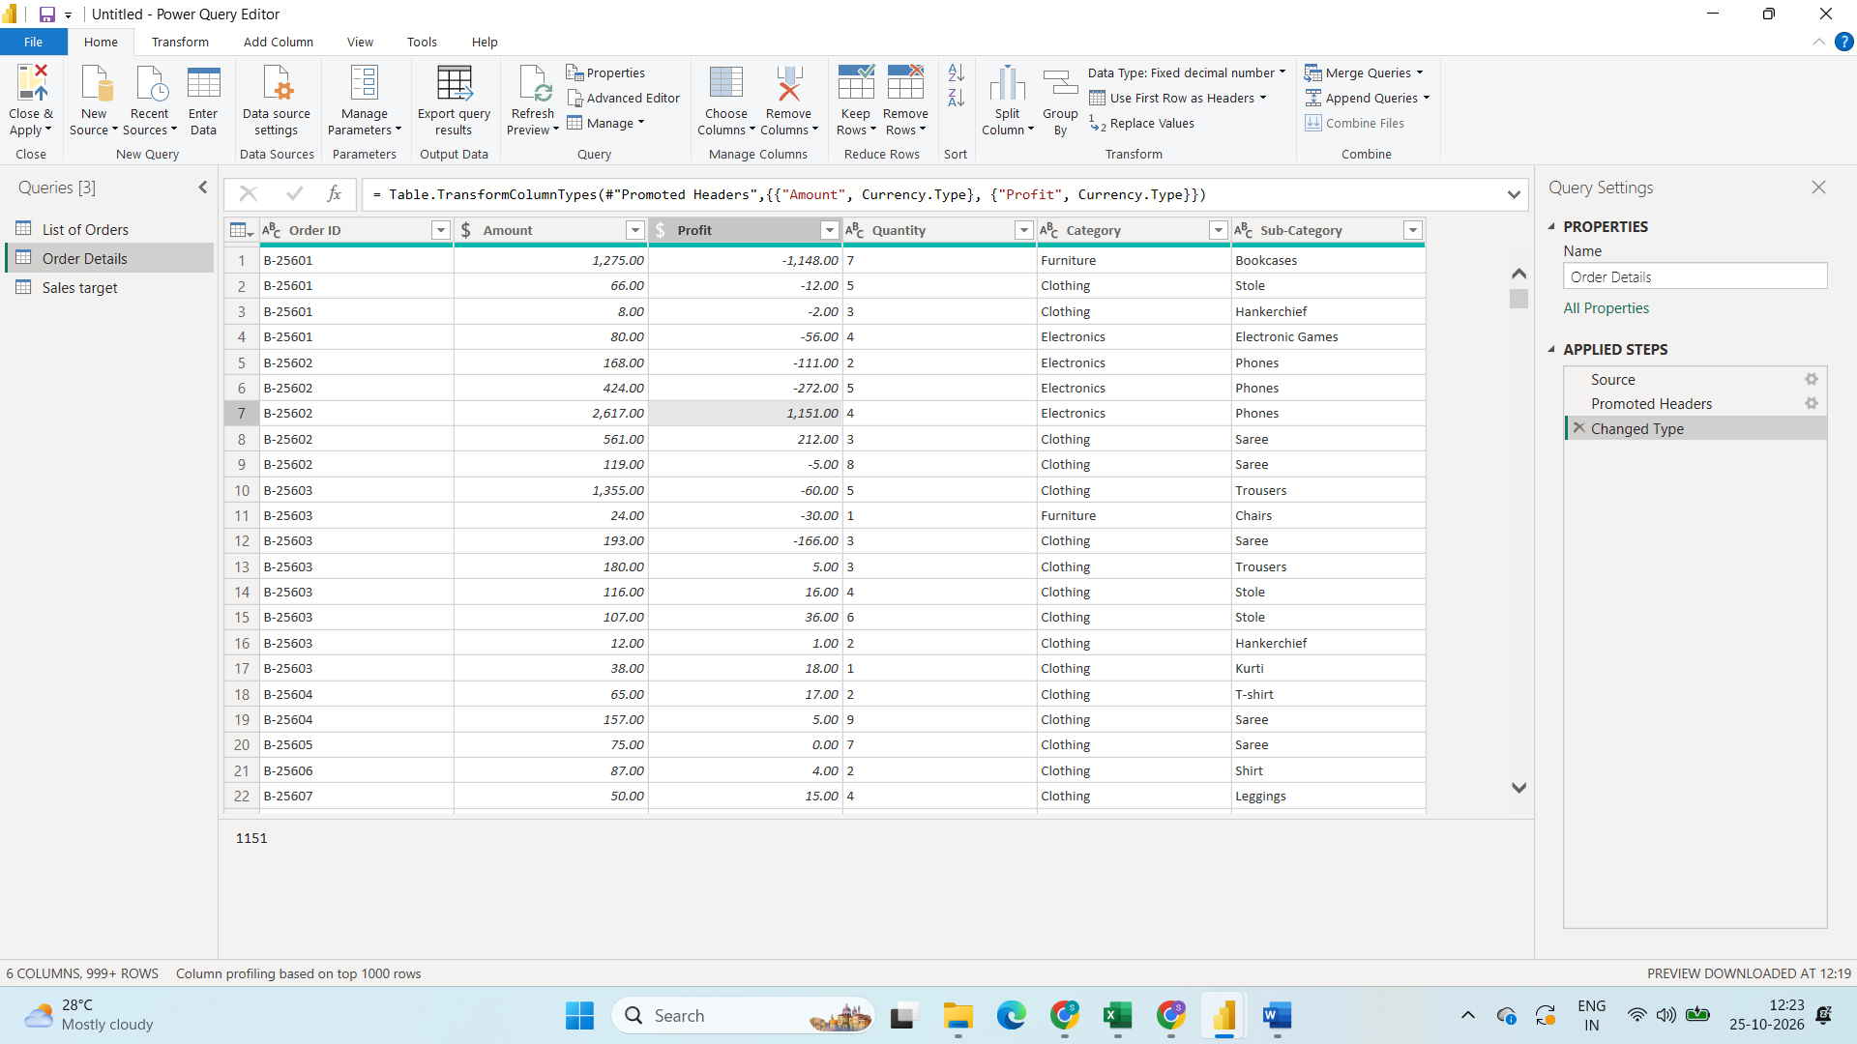
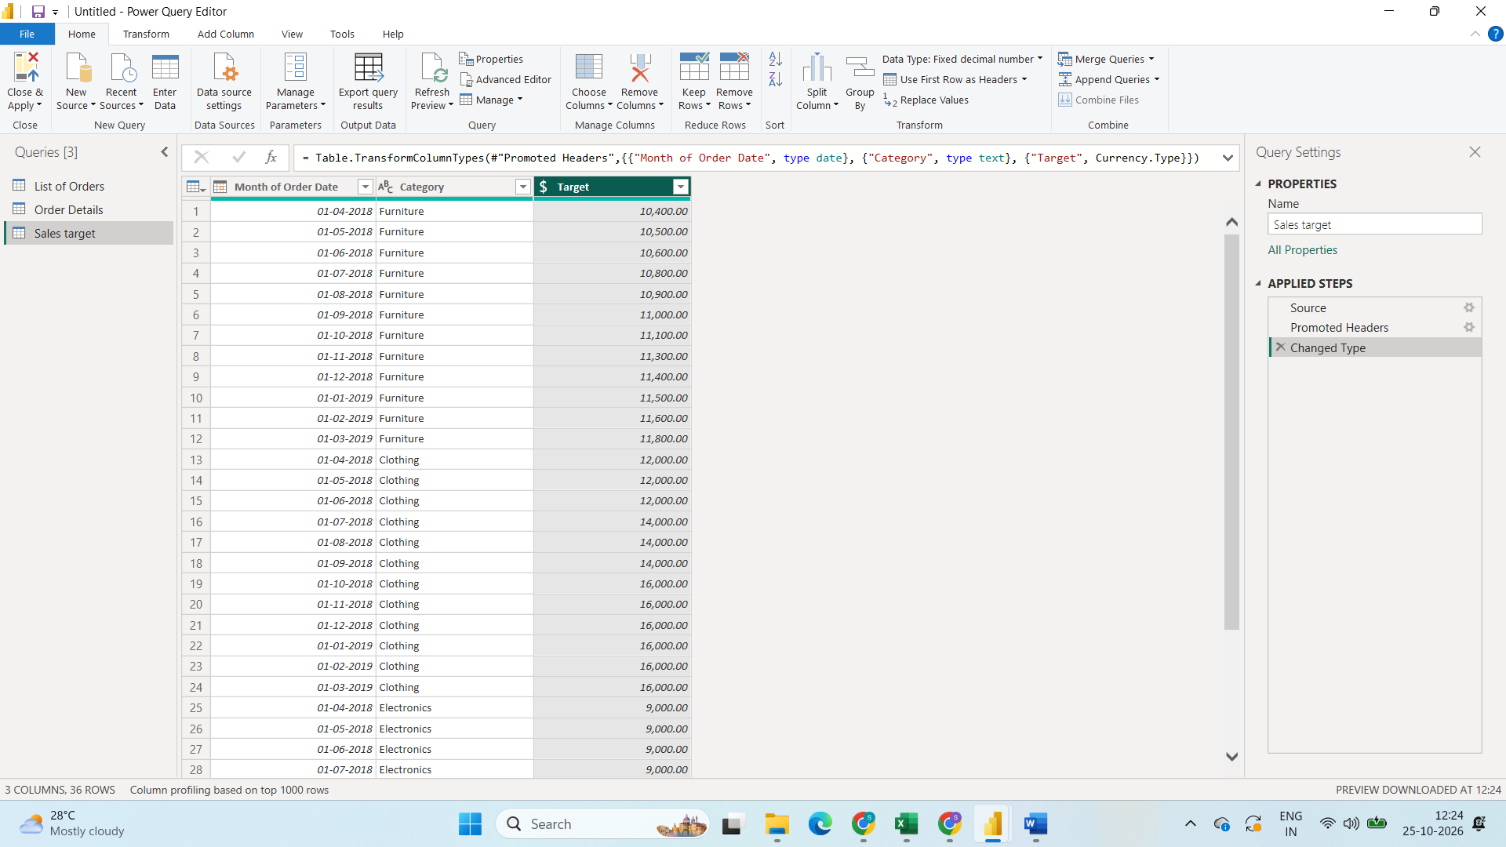
Import All data set into power Querry and checking for the Data types and correcting the Data type in Oreder details amount and profit column and Sales Target - Target Column into fixed decimal number to convert into currency type
Step2:
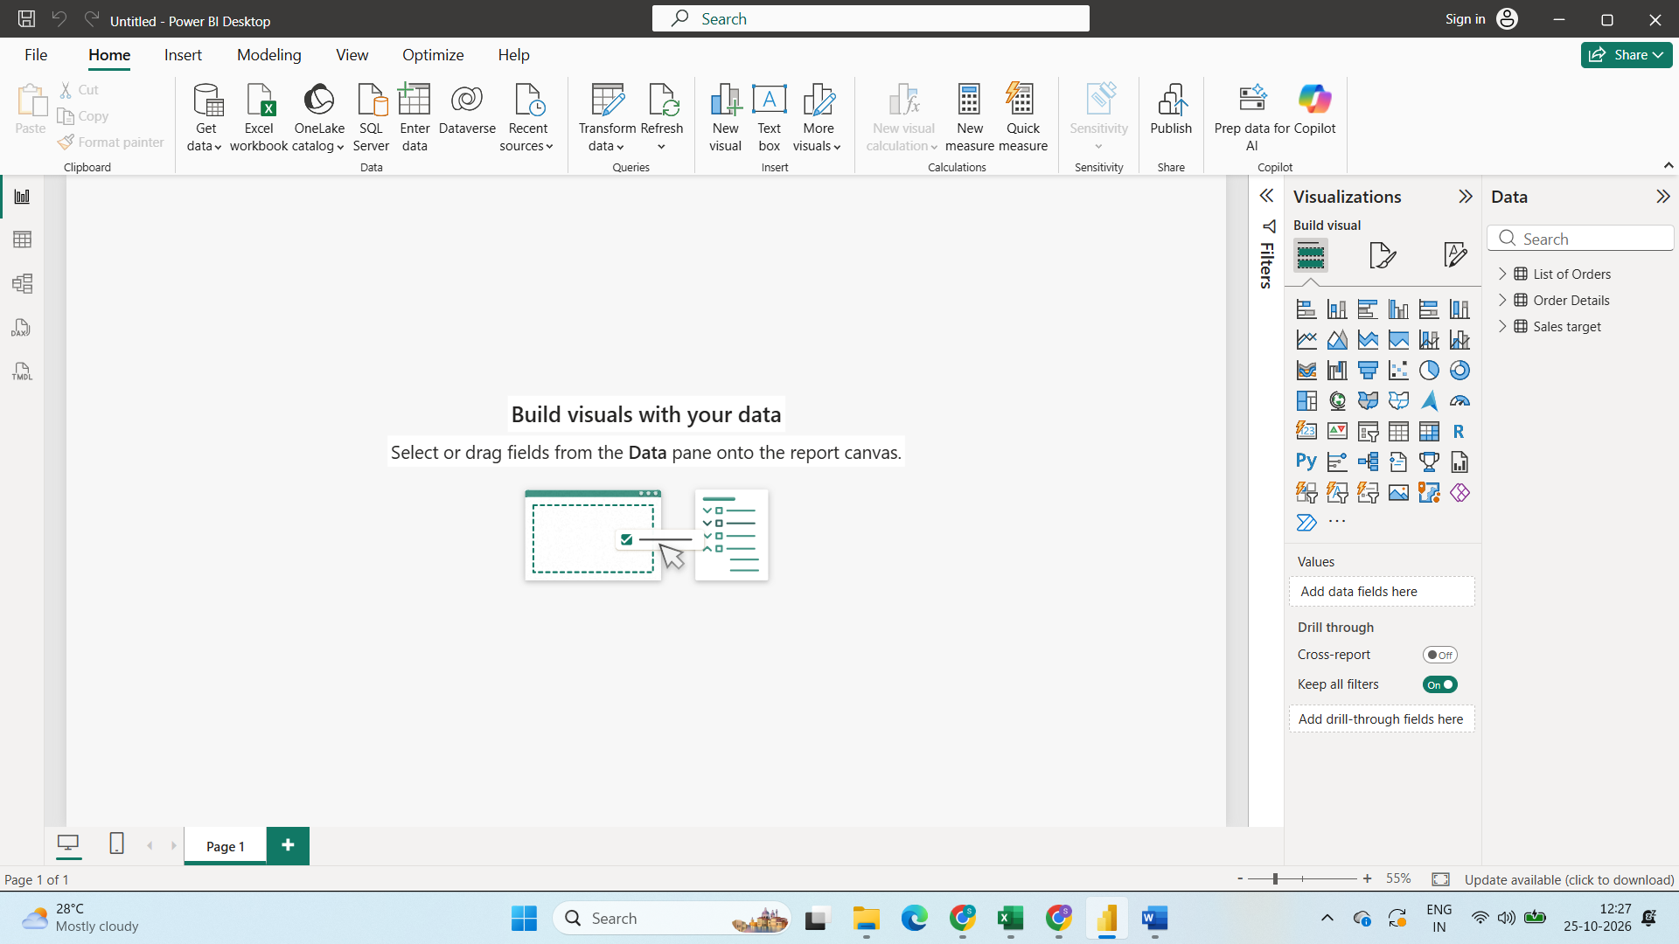
Close and load to Power BI
Step3:
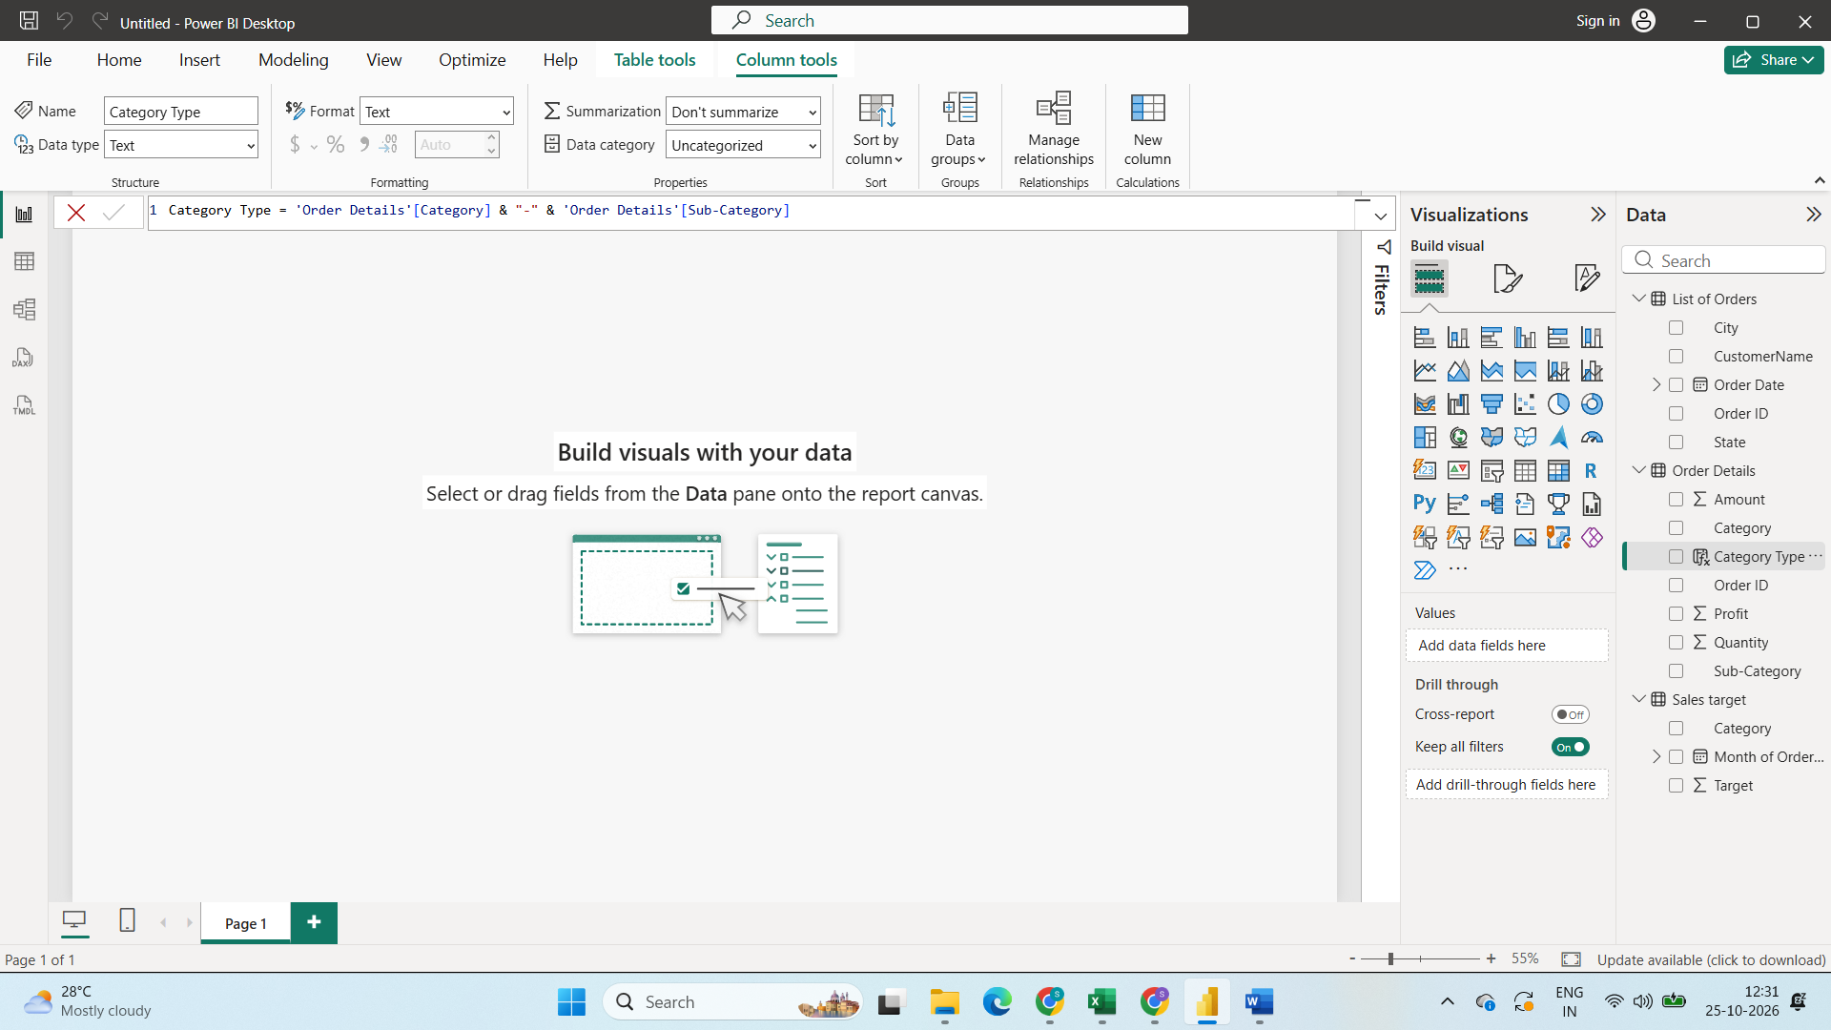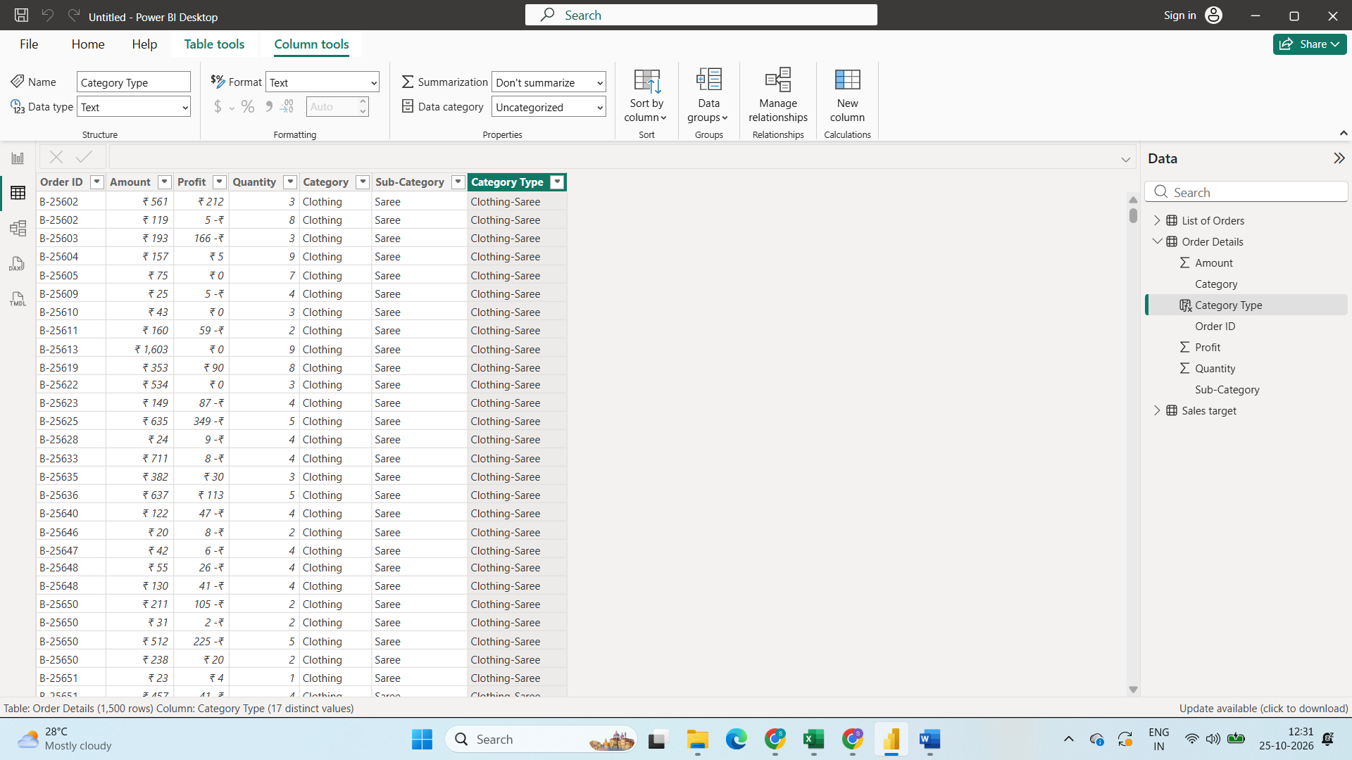
Created Category Type Column with category and Sub category
Get into column tools create new column renamed as category type and used
Dax Function Category Type = 'Order Details'[Category] & "-" & 'Order Details'[Sub-Category]
Step4:
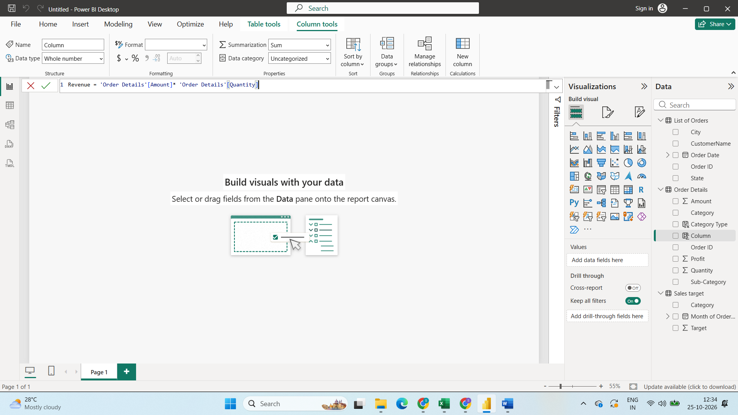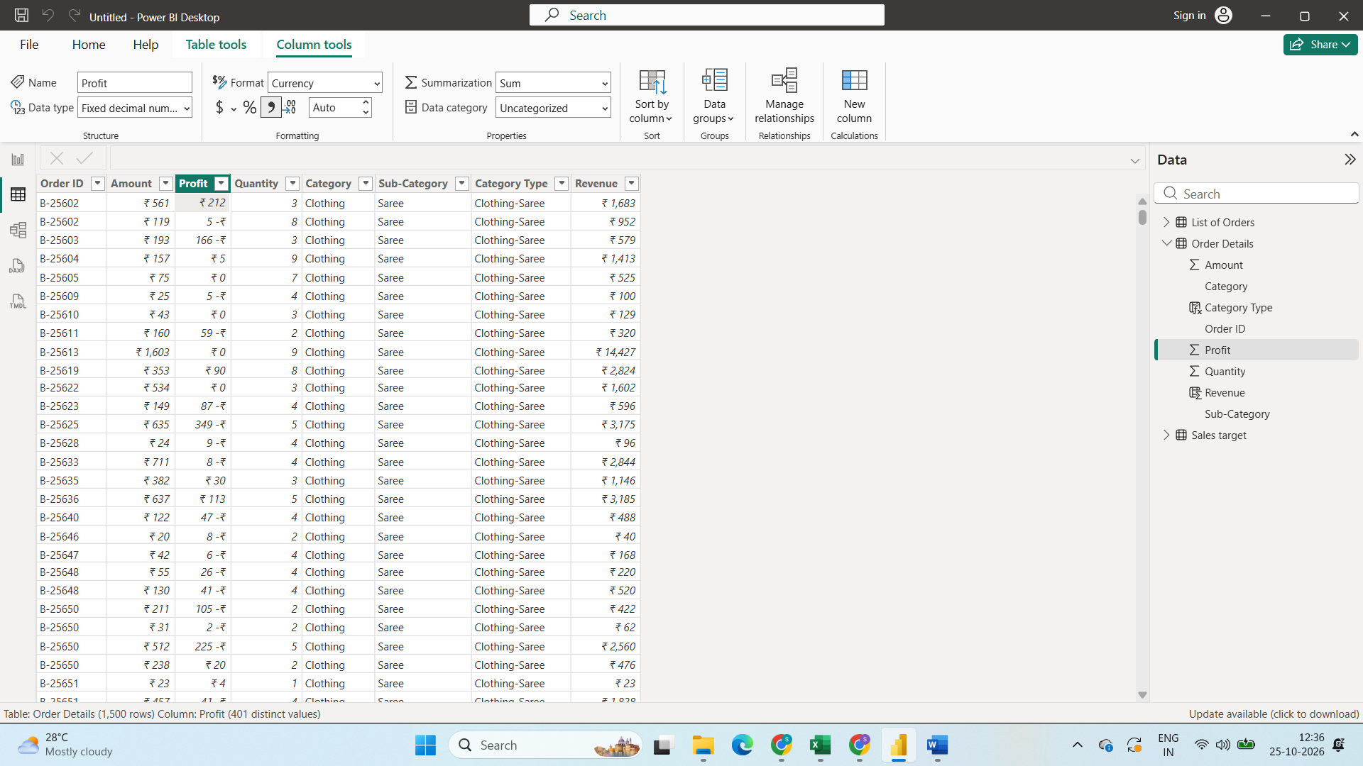

Created Revenue Column in Order details
With Dax Function Revenue = 'Order Details'[Amount]* 'Order Details'[Quantity]
Step5:
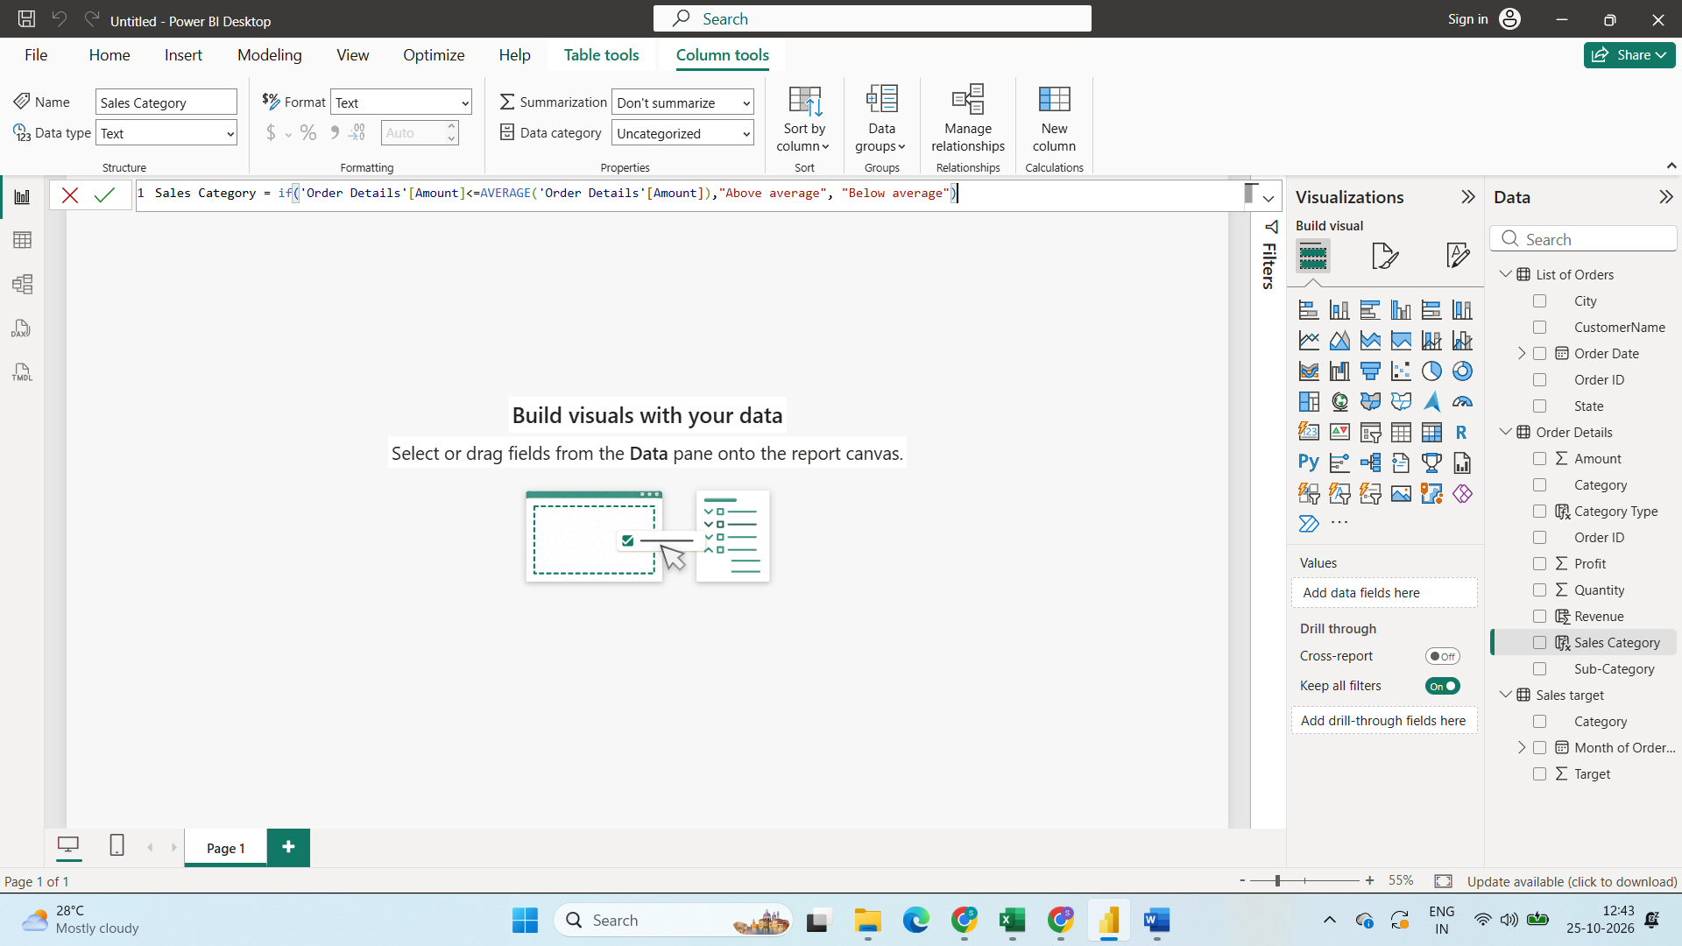
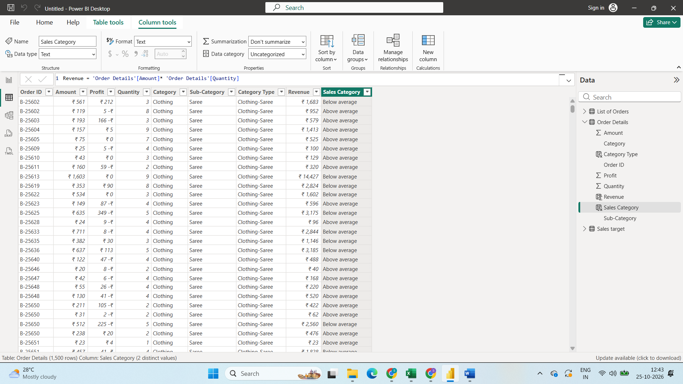
Created a new column sales category with the order details Amount Average
Using Dax function Sales Category = if('Order Details'[Amount]<=AVERAGE('Order Details'[Amount]),"Above average", "Below average")
If the order Amount <= Average of order amount it will be Above Average or else it will be below Average
Step5:
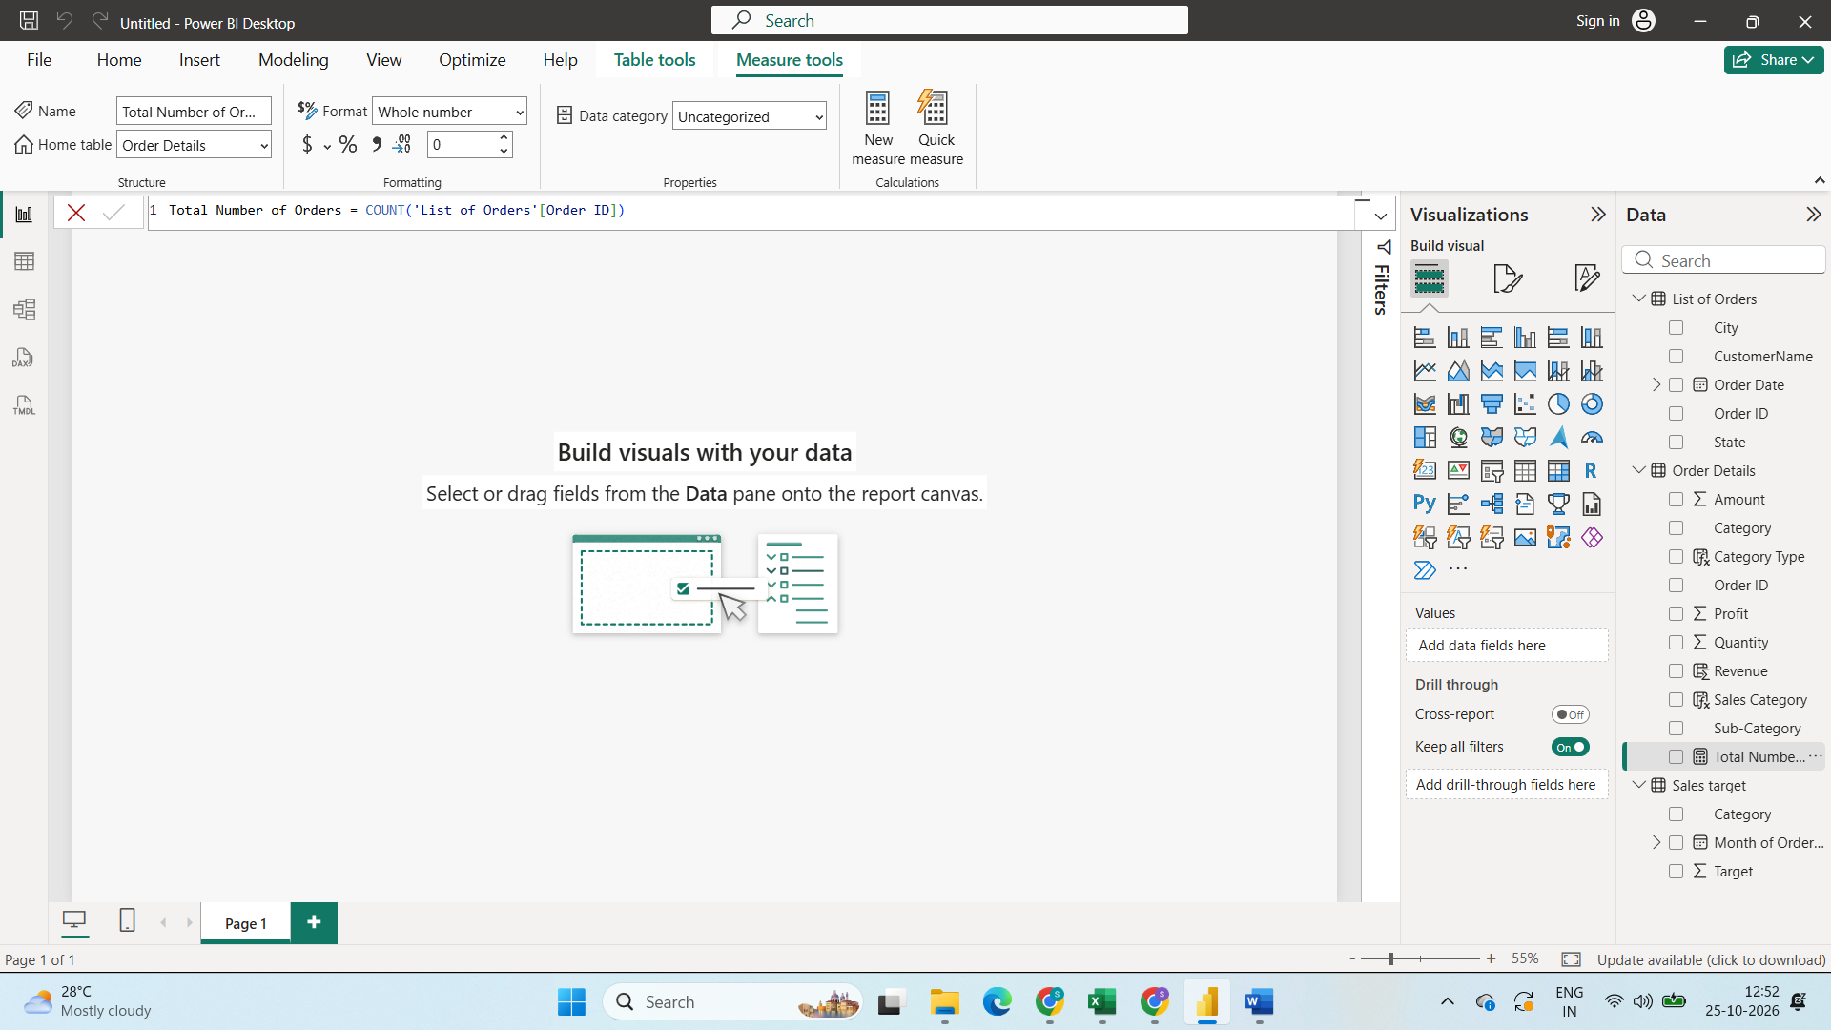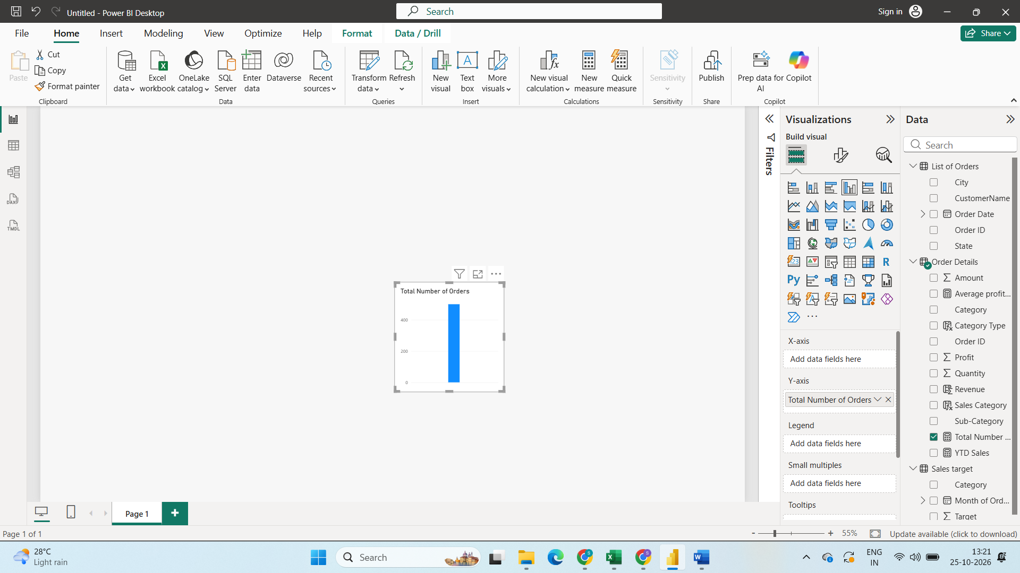
Created a new total number of order by Total Number of Orders = COUNT('List of Orders'[Order ID])

Step6:
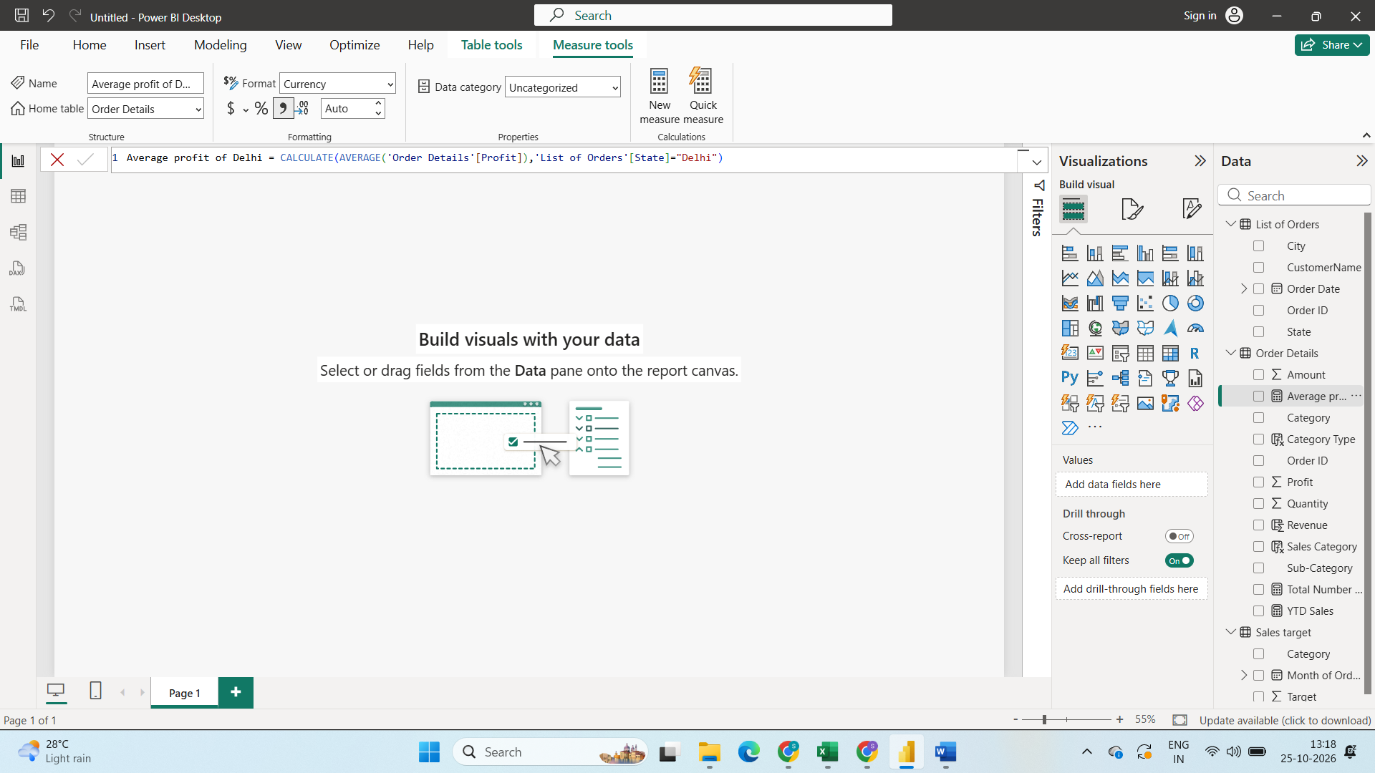
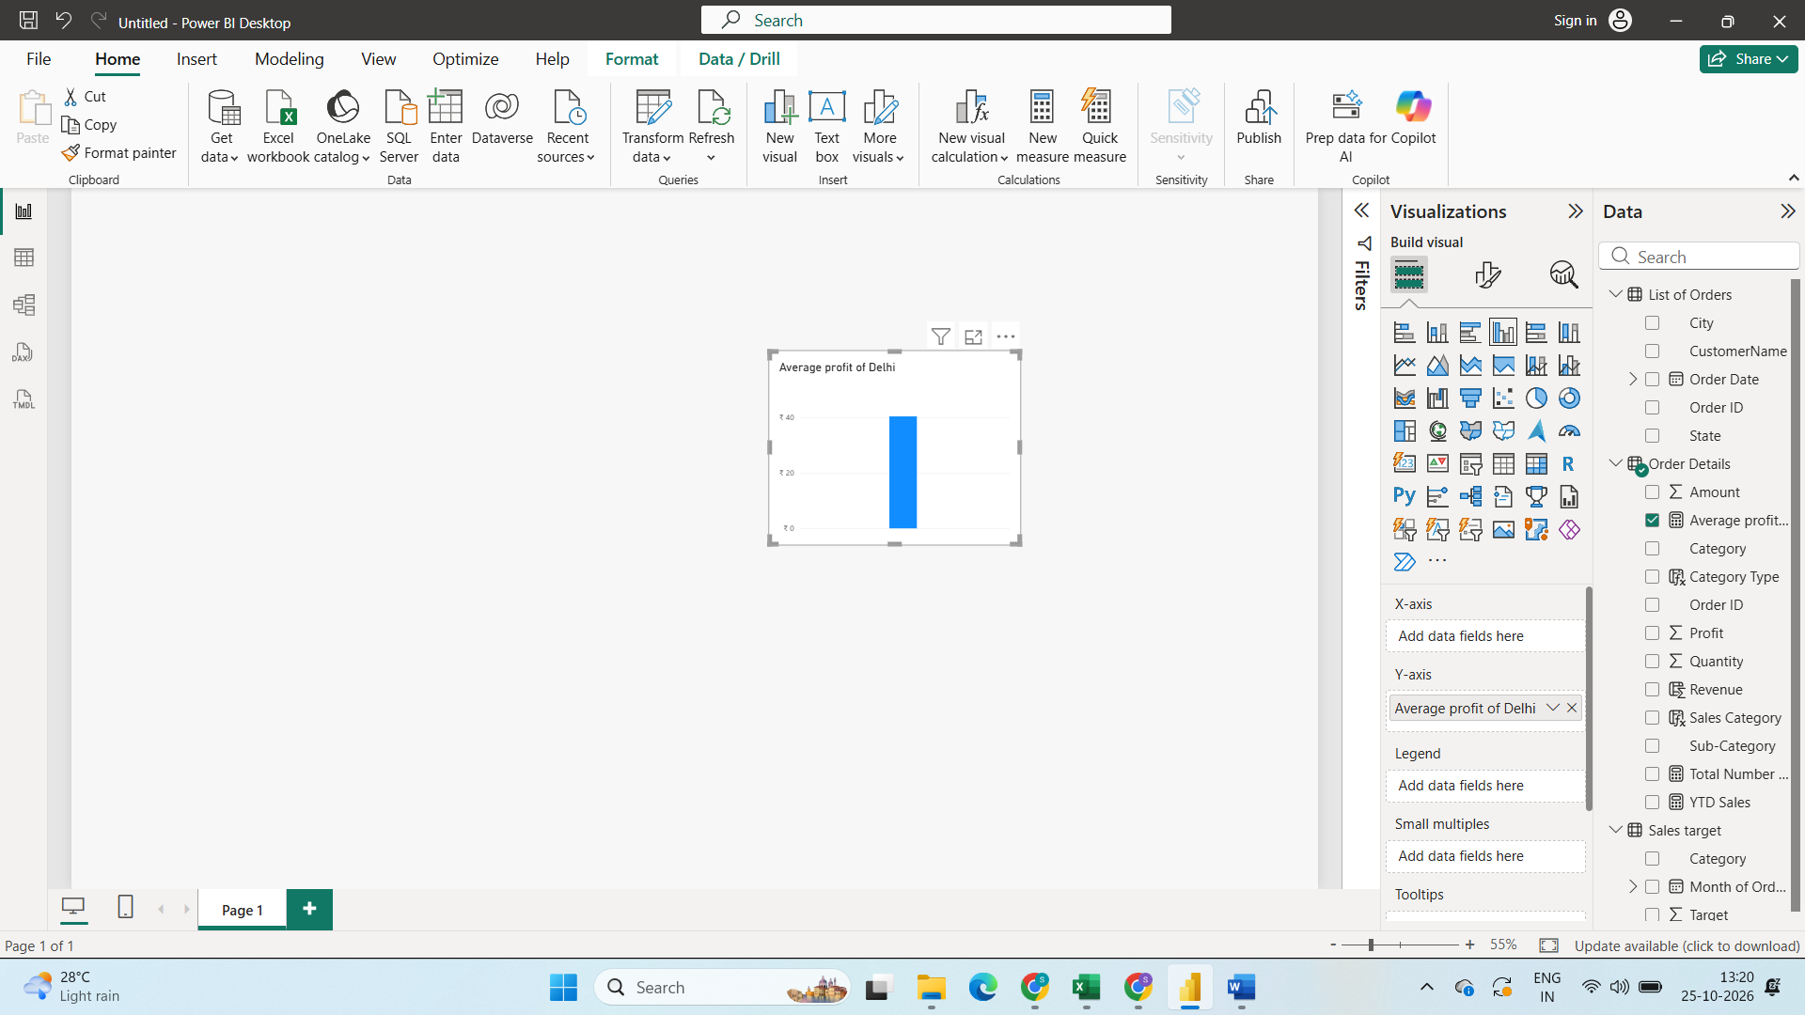
Calculate Average profit of delhi using DAX function
Average profit of Delhi = CALCULATE(AVERAGE('Order Details'[Profit]),'List of Orders'[State]="Delhi")
Step7:
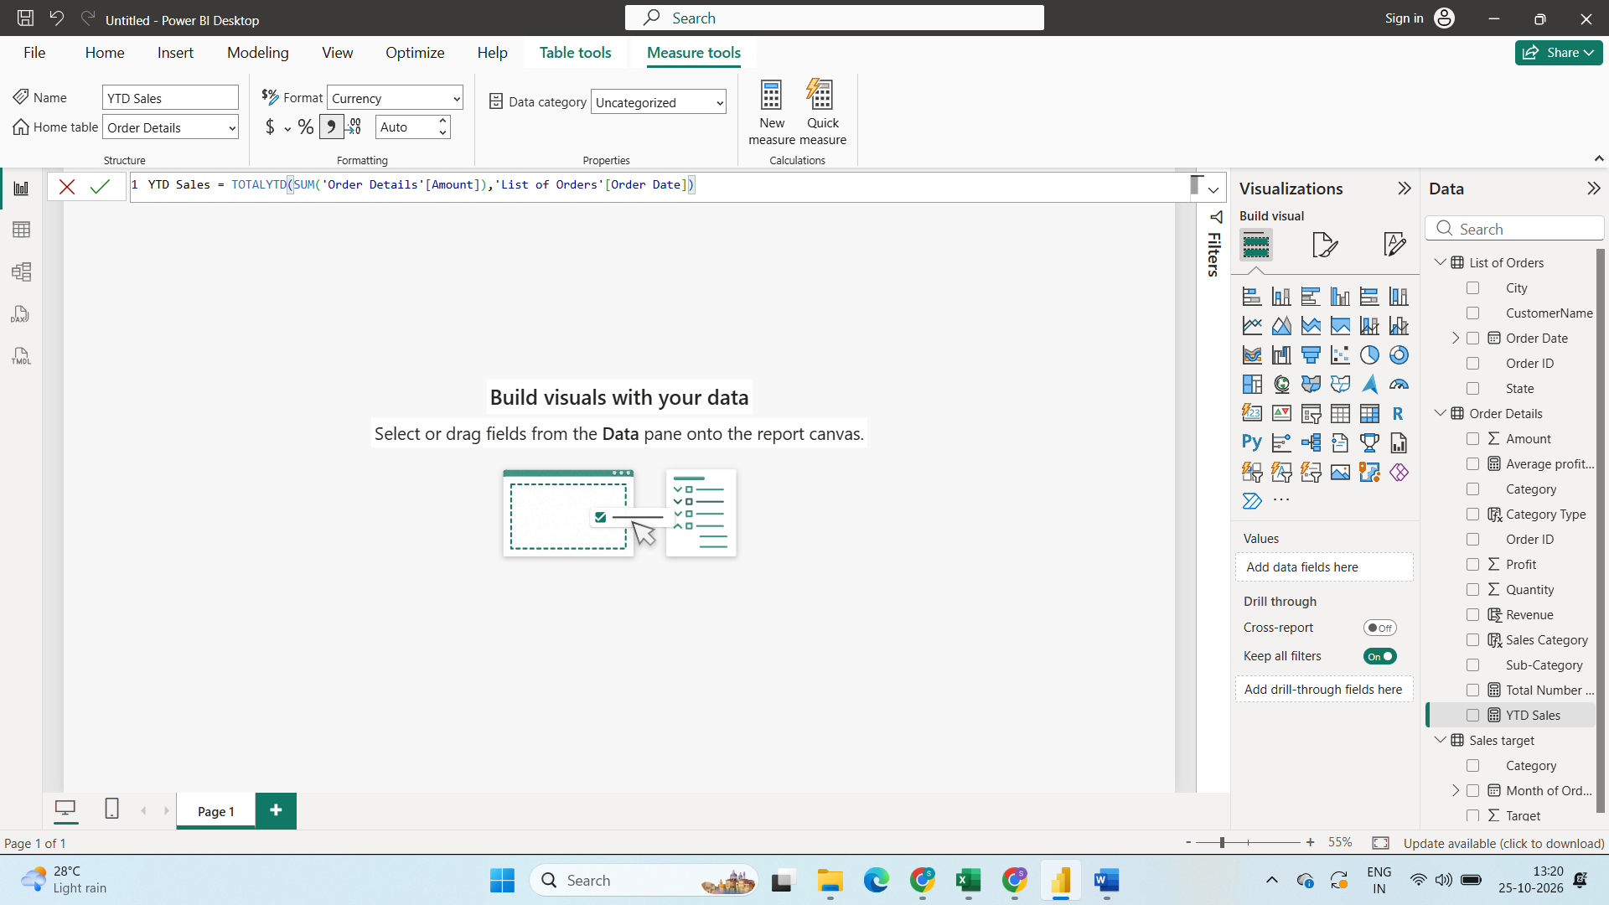
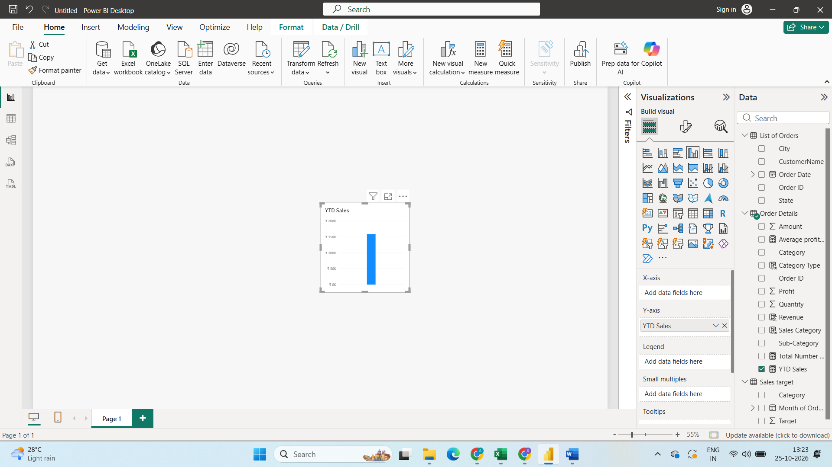
Calculated YTD Sales
Using Dax Function YTD Sales = TOTALYTD(SUM('Order Details'[Amount]),'List of Orders'[Order Date])
Step8:
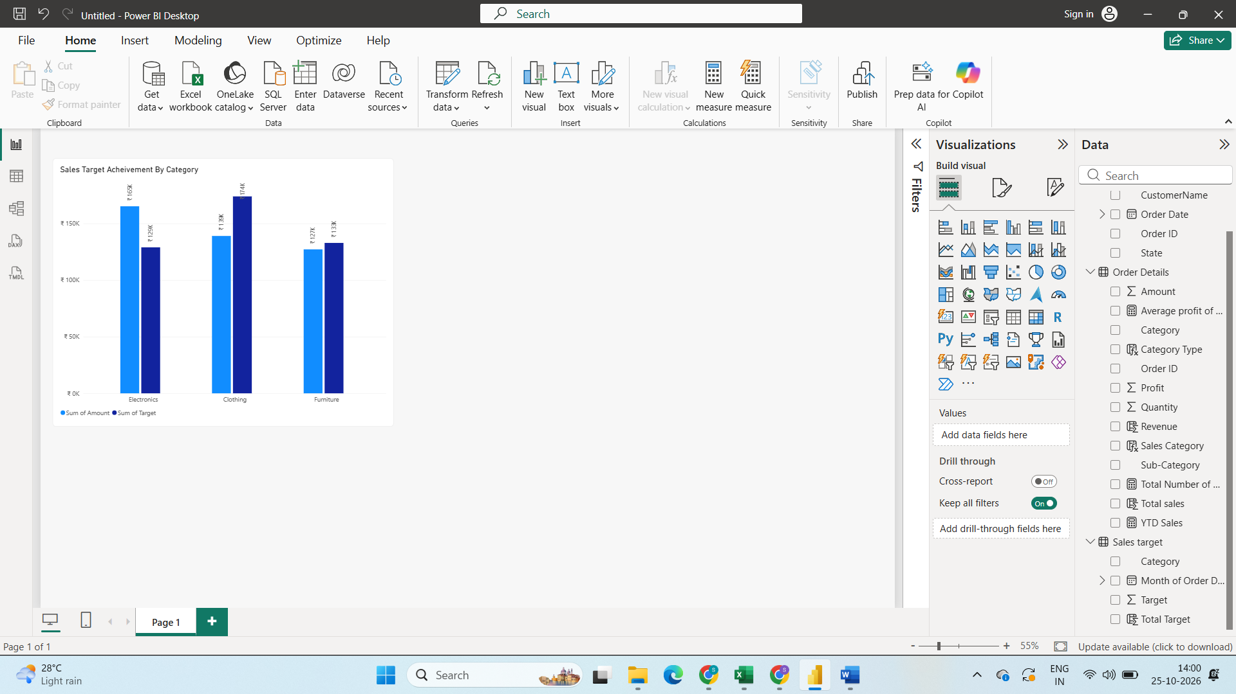
Calculating the Sales and target By using cluster column chart
X Axis Category , Y Axis Sum of total Amount of order details and Sum of total target in Sales Target.

Step9:
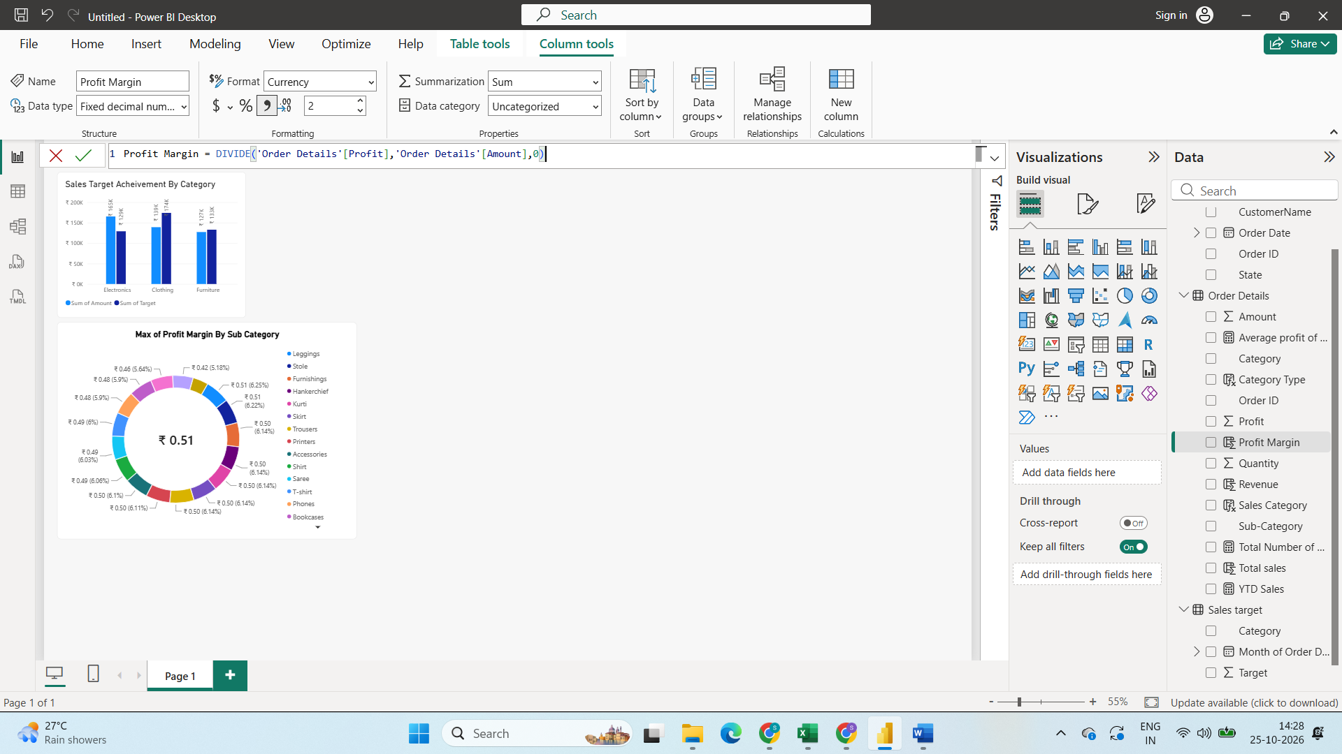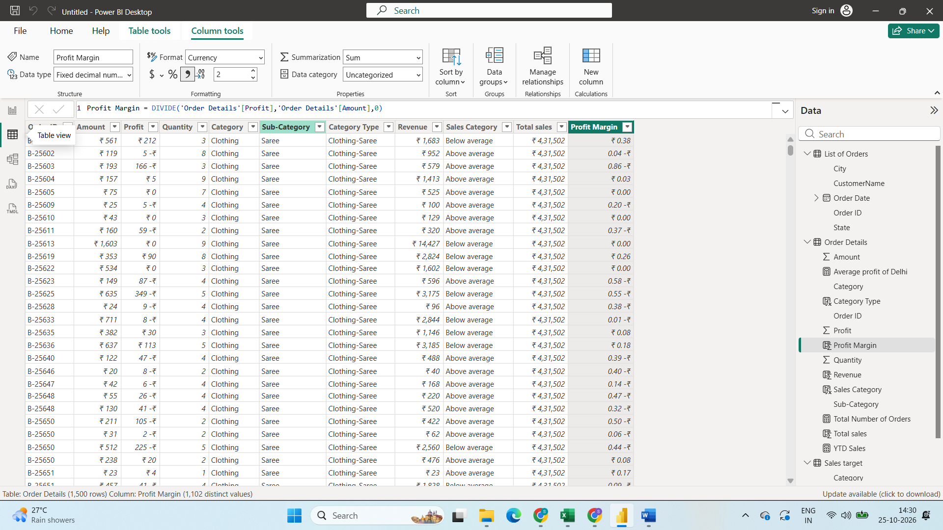
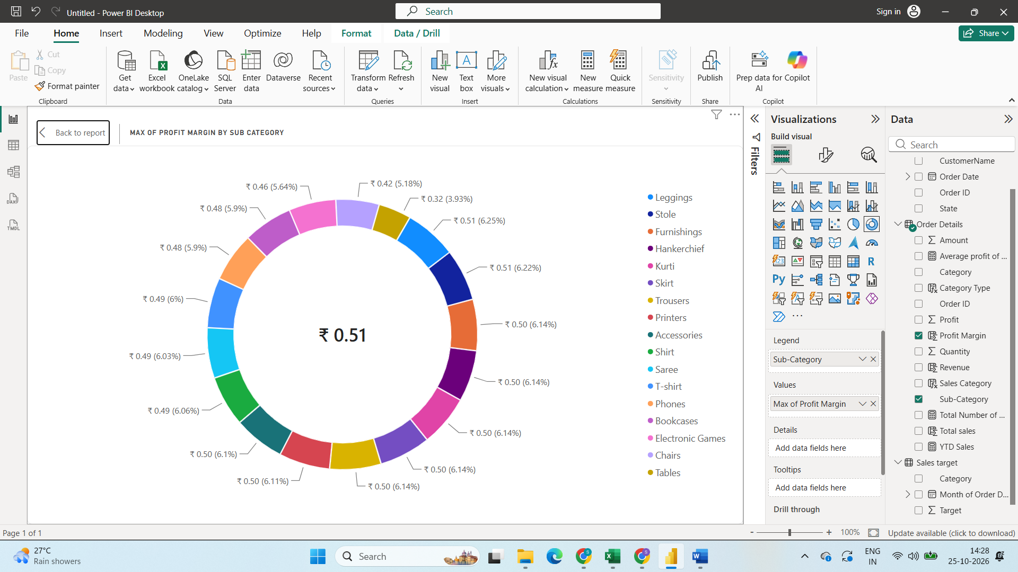
Created Donut chart to Analyse Profit Margin By sub category
created new Column as Profit Margin By using Dax function Profit Margin = DIVIDE('Order Details'[Profit],'Order Details'[Amount],0)
Then Click on Donut chart give legend as sub Category and Values as Profit Margin
Step10:
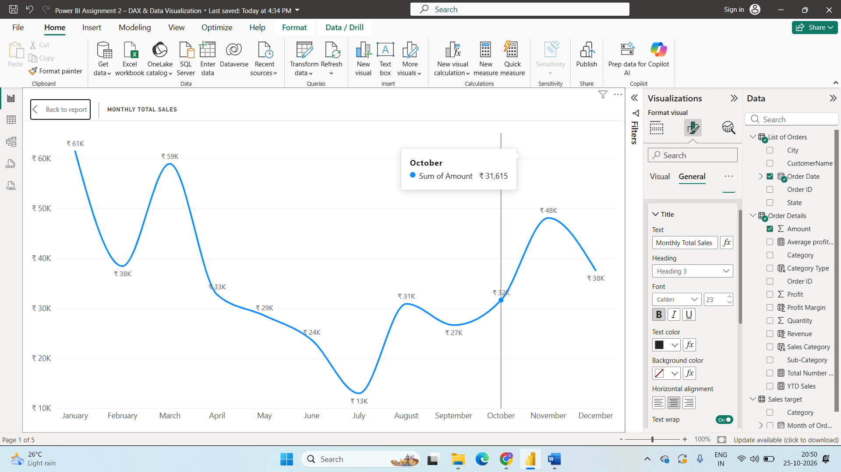
Created line Chart to Monthly Total Sales
X asis will be order Month And Y Axis will be Sum of Amounts
Step11: 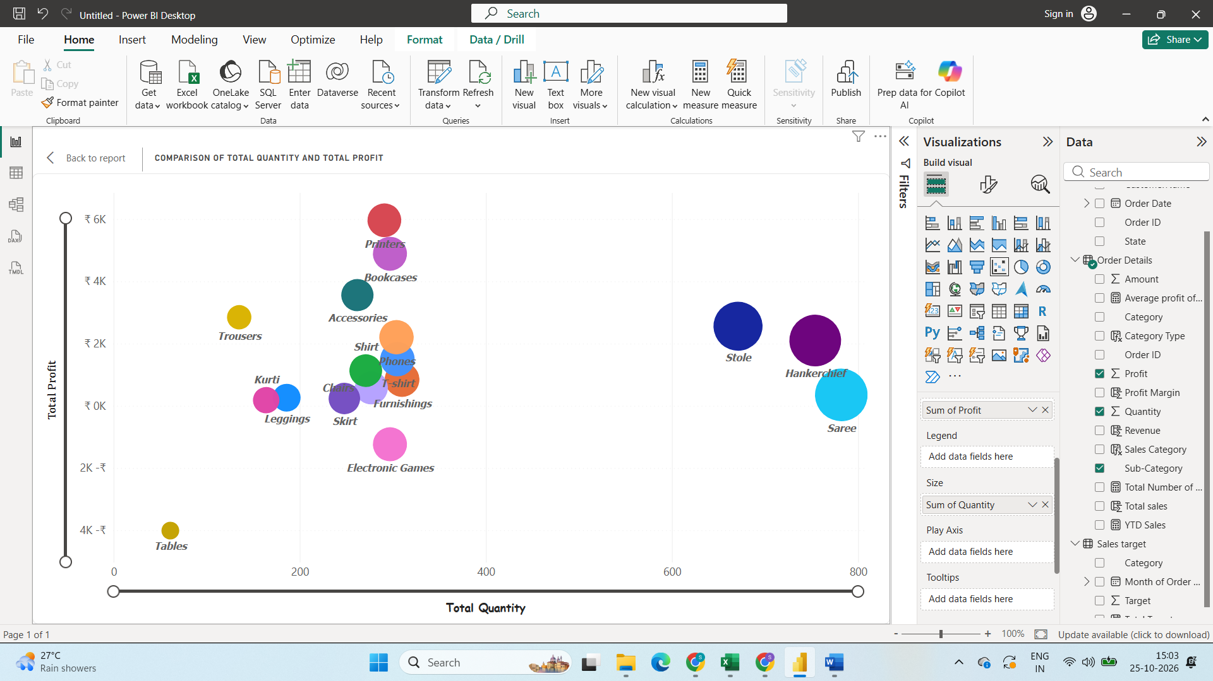
Compared Total Profit and Total Quantity By using Scatter Chart
X Axis will be Total Quantity and Y Axis will be total Profit and Details will be Sub Category
Size is total Quantity
Step12:
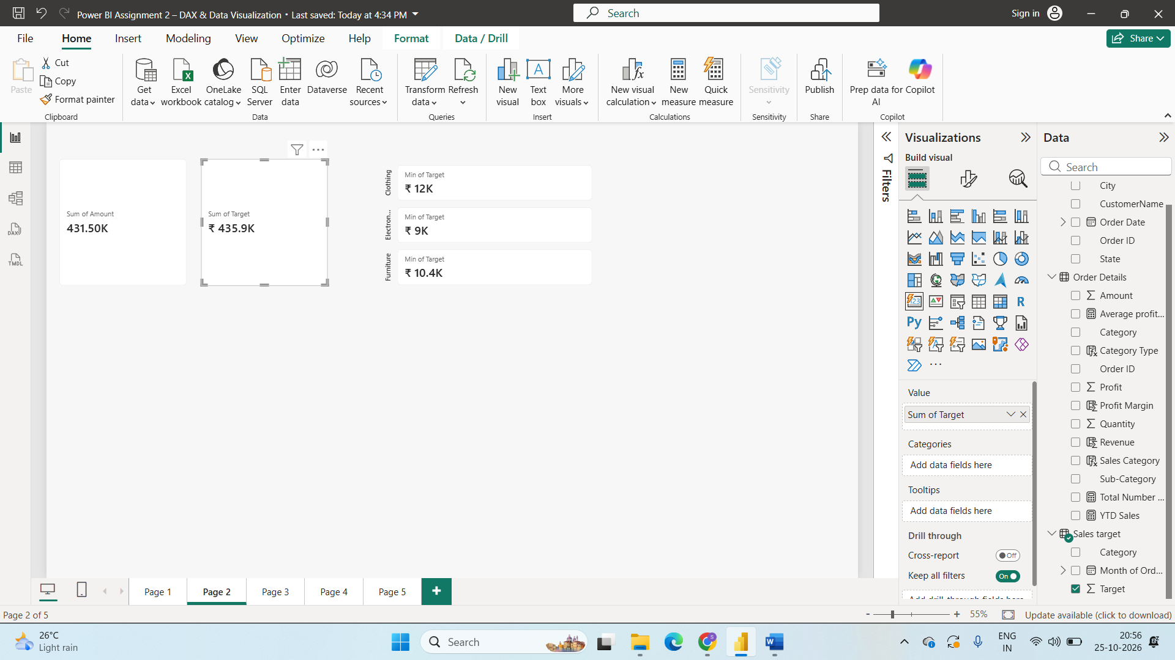
Comparison Total Sales And Total Target By Using Cards
Visualize Category wise Minimum Sales target Using Cards
Value is Minimum of Total Target and Categories is Category.
Step13:
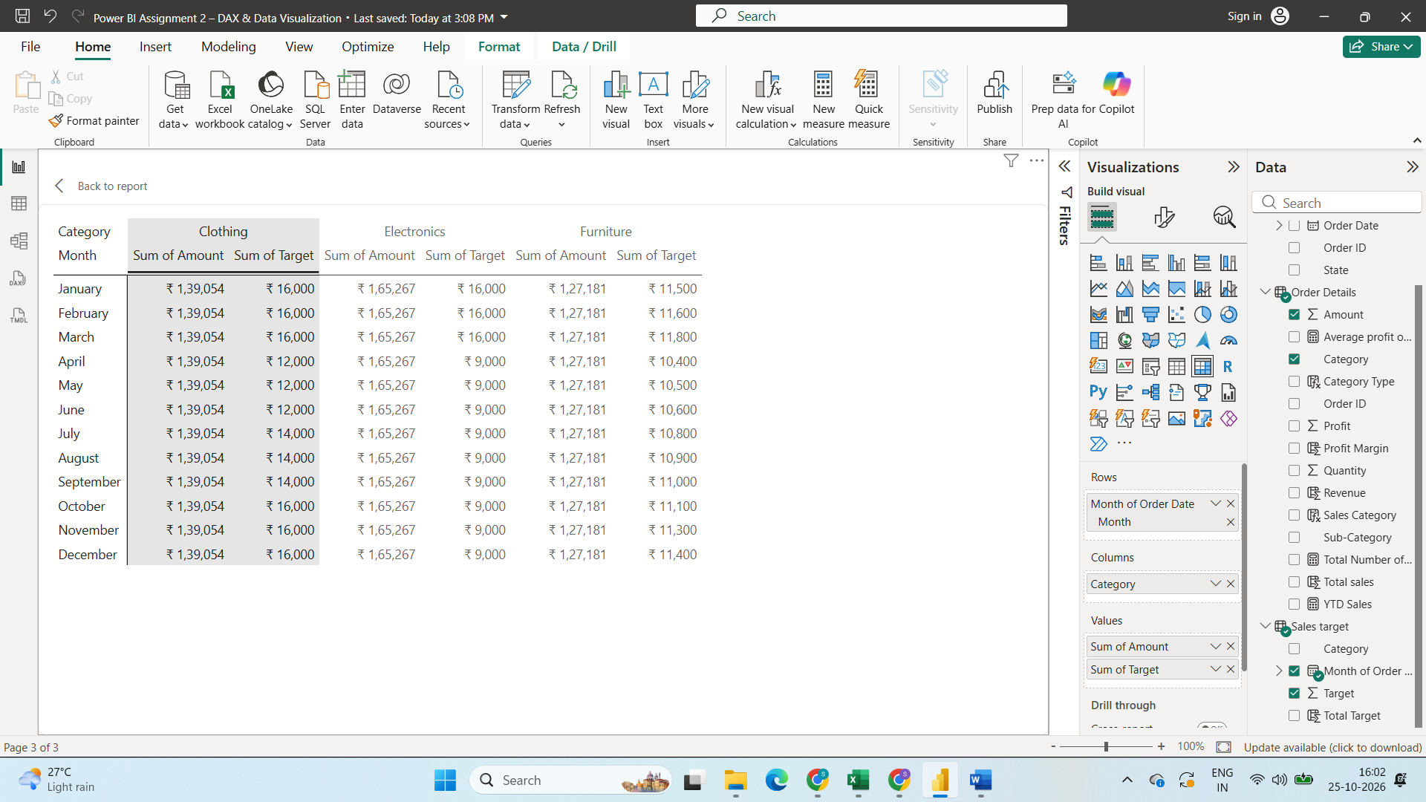

Sales Performance Matrix with Matrix chart
Rows is Month of order date and Column is Category and
Values is Sum of Amount and Sum Of Target.

Step14:
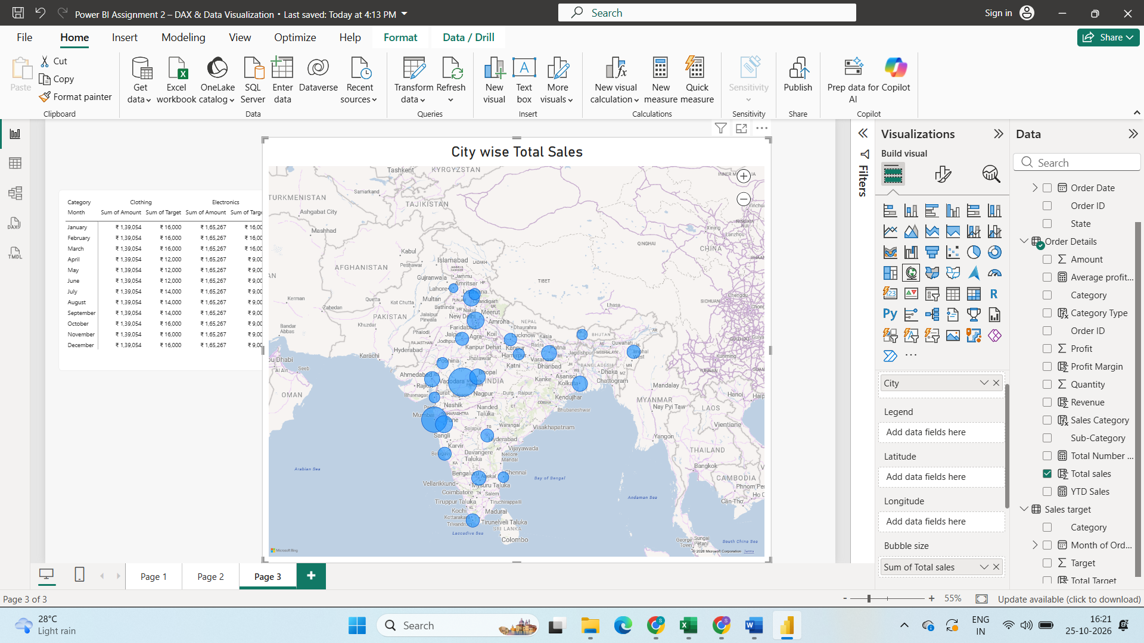
By Using Map Chart Visualize City wise Total Sales
Step15:
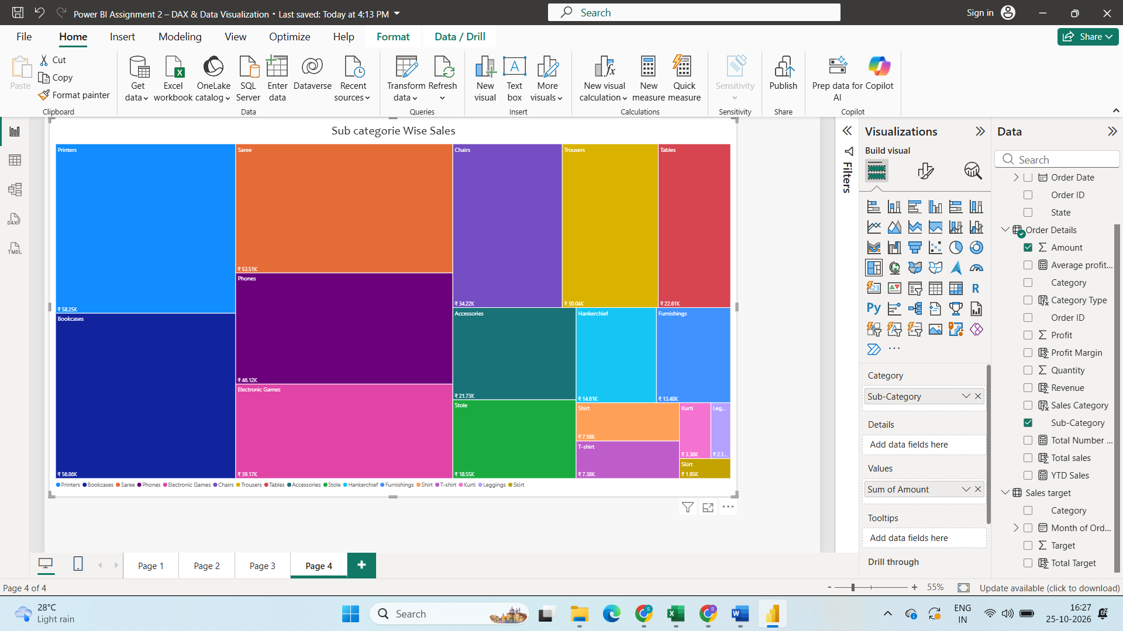
Visualize Subcategories Wise Sales Using Tree Map Chart
Category is SubCategory and Values Sum of Amount
Step16:
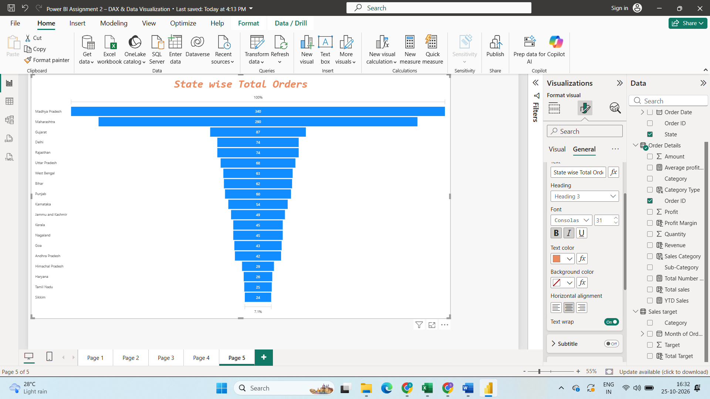
Visualize State wise Total orders with Funnel Chart
Categorie – State
Values – Count of Order ID

